– Entropy

– Energy (Angular Second Moment)

– Contrast

– Homogeneity

– SumMean (Mean)

– Variance

– Correlation

– Maximum Probability

– Inverse Difference Moment

– Cluster Tendency

– Inertia

–Difference-mean

– Sum-Entropy

– Difference-entropy

– Mean grey-level intensity (MGI)

– Uniformity

Histogram parameters:

Mean, SD, Skewness, Kurtosis

CT texture analysis using the filtration-histogram method: what do the measurements mean?

https://www.ncbi.nlm.nih.gov/pmc/articles/PMC3781643/

1. All

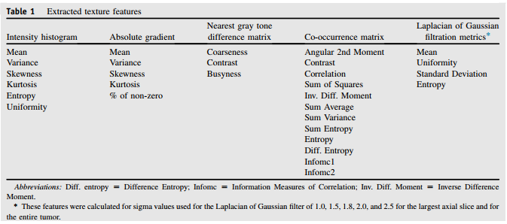

NGTDM:

* Coarseness
* Contrast
* Busyness
* Complexity
* Strength

(NGTDM - MATLAB CODE)

<https://www.mathworks.com/matlabcentral/fileexchange/37744-abhi>

Neighboring gray-level dependence matrix (NGLDM) in MATLAB

<https://stackoverflow.com/questions/25019840/neighboring-gray-level-dependence-matrix-ngldm-in-matlab>

Prognostic Value and Reproducibility of Pretreatment CT Texture Features in Stage III Non-Small Cell Lung Cancer

http://www.redjournal.org/article/S0360-3016(14)03499-3/pdf

* First order histogram features: mean, median, maximum, minimum, mean absolute deviation, range, interquartile range, standard deviation, skewness, kurtosis, energy, entropy, binned entropy.
* Fractal features: Three methods to compute the fractal dimension were used: the blanket method, the Brownian motion method, and the box-counting method.
* Fourier features: The first moment of the power spectrum and rootmean-squared variation were measured.27 Using the rotationally invariant Fourier transform of a region, the energy of the transformed region and the energy of several subspaces representing specific frequency components were computed
* GLCM: correlation, inertia, absolute value, inverse difference, energy, entropy, contrast, sum of squares variance, sum average, sum variance, sum entropy, difference average, difference variance, and difference entropy.

Lung texture in serial thoracic CT scans: Assessment of change introduced by image registration

https://www.ncbi.nlm.nih.gov/pmc/articles/PMC3411586/pdf/MPHYA6-000039-004679_1.pdf

GLRLMS

The number of times a gray level at certain length happens in an image

Texture Analysis and Description in Linguistic Terms

<http://staff.itee.uq.edu.au/lovell/aprs/accv2002/accv2002_proceedings/Lin205.pdf>

Texural Features Corresponding to Texural Properties

<http://ieeexplore.ieee.org/stamp/stamp.jsp?arnumber=44046>

Computational Perceptual Features for Texture Representation and Retrieval

<http://ieeexplore.ieee.org/stamp/stamp.jsp?arnumber=5518430>

TEXTURE FEATURE EXTRACTION

<http://shodhganga.inflibnet.ac.in/bitstream/10603/24460/9/09_chapter4.pdf>

NORMALIZED GREY-LEVEL CO-OCCURRENCE MATRIX (NGLCM)

<http://jnm.snmjournals.org/content/suppl/2013/09/19/54.10.1703.DC1/119289_Supplemental_Data.pdf>